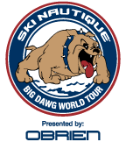
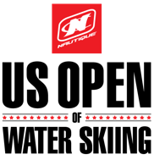
2016 Nautique Big Dawg Finals Friday, September 30, 2016

Running Order

Turnpike Lake
8:00 AM Big Dawg 2 Rounds
- George Levien
- Mike Dehlinger
- Mike Kusiak
- Mark Brandt
- Dave Goode
- John Shealy
- Kyle Jones
- Kevin Bishop
- Ben Favret
- Jeremy Newby-Ricci
- Fotis Dulos
- Paul Turner
- Barton Rachwal
- Todd Johnson
- Tim Henderson
- Don Aschenbrenner
- Kris LaPoint
- Todd Ristorcelli
- Marco Bettosini
- Jason Seels
- Robert Marking
- Seth Stisher
- Darin Montogomery
- Todd Kuykendall
- Jeff Kepchia
- Kyle Tate
- Marc Shaw
- Bruce Dodd
- Tim Huston
- Jay Leach
- Harald Hintringer
- Frederic Halt
- Greg Badal
- Dave Miller
- Greg Sund
- Chad Scott
- Jeff Rodgers

